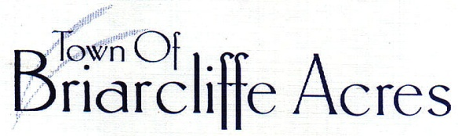

GFL OPTIONAL YARD DEBRIS PROGRAM

YEARLY RATE $108.00
ADDITIONAL CART $9.00/MONTH

Residents who wish to enroll or upgrade with additional carts can contact the local GFL office @ 843.397.5586, or via their website @ https://myaccount.gflenv.com (submit an online request and a representative team member will reach out to assist).

Office of Town Clerk 121 North Gate Road Myrtle Beach, South Carolina 29572 843.272.8863

